31 August 2011
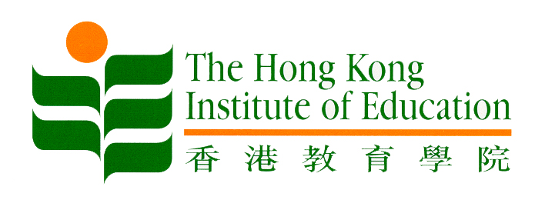
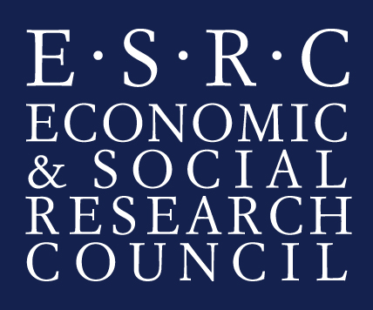

Is the poverty gap widening in Hong Kong?
New study to examine extent of poverty and social exclusion in Hong Kong

Hong Kong and UK researchers today launched an international collaboration to measure poverty and social exclusion in Hong Kong.

The two-year study, led by academics at The Hong Kong Institute of Education (HKIEd) and the University of Bristol, will examine whether the introduction of recent policies, such as the minimum wage legislation, have significantly improved people’s living standards.

This research will be supported by the Hong Kong Council of Social Service (HKCSS) and will assess the extent and nature of poverty and social exclusion in Hong Kong.

This new project is funded by University Grants Committee of Hong Kong and the Economic and Social Research Council (ESRC), the investigation will be led by Dr Maggie Lau, Assistant Professor of the Department of Social Science at the HKIEd, and Professor David Gordon, Director of the Townsend Centre for International Poverty Research at the University of Bristol.

Professor Mok Ka-ho, Dean for the Faculty of Social Science at the HKIEd said, “I am delighted that this major new research project will build upon our already strong international collaboration between Hong Kong and UK academics on the important topic of reducing poverty and exclusion.”

Professor David Gordon said, “All the governments of the world have recognised the need to reduce, and eventually eradicate, poverty during the 21st century. New and innovative research is needed into the causes and solutions to poverty so as to provide policy makers with the key evidence they require. This research project will provide up-to-date and scientifically rigorous information on poverty and exclusion in Hong Kong.”

Mr Chua Hoi-wai, Business Director (Policy Advocacy and Social Enterprise) of HKCSS welcomed the collaboration with the academic community saying: “This study represents a unique opportunity to track changes in people’s circumstances over time and facilitate policy advocacy in the crucial area of poverty alleviation.”

The research project will:
1. Develop a new poverty and social exclusion survey and enhance collaboration between researchers in Hong Kong and Britain,
2. Improve the measurement of poverty, deprivation, social exclusion and standard of living in the Chinese context, and
3. Conduct policy-relevant analyses of interest to both the general public and government.

Dr Lau welcomed the opportunity to work with the Bristol University team and other national and international experts saying: “that the collaboration would advance the measurement of poverty and exclusion in the Chinese context by using state-of-the art methodology.”

Dr Christina Pantazis from the University of Bristol said “the study represented an important opportunity to update and improve knowledge about poverty and exclusion in Hong Kong and also provide evidence for regional and international comparisons.”

Further information:
The ESRC/RGC Bilateral Grant (RES-000-22-4400) on Poverty and Social Exclusion in Hong Kong starts on the 1st September 2011 and will last 24 months. The survey will re-interview respondents to a HKCSS 2011 Survey to see how people’s lives have changed. The project will build on the Survey of Living Standards in Hong Kong undertaken in 2000, and the expertise in measuring social exclusion at Bristol University, including the UK Poverty and Social Exclusion in the UK project (RES-060-25-0052).

The University Grants Committee of Hong Kong (UGC) is the non statutory body which advises the Government of the SAR on the funding and strategic development of higher education in Hong Kong. In this role, the UGC works with Institutions, the Administration and the Community to promote excellence in the higher education sector, with a view to establishing Hong Kong as the education hub of the region and to nurturing high quality people to promote the economic and social development of Hong Kong.

The Economic and Social Research Council (ESRC) is the UK's largest organisation for funding research on economic and social issues. It supports independent, high quality research which has an impact on business, the public sector and the third sector. The ESRC's total budget for 2011/12 is £203 million. At any one time the ESRC supports over 4,000 researchers and postgraduate students in academic institutions and
independent research institutes. More at www.esrc.ac.uk

~ends~

For media enquiries, please contact:
Dr Maggie Lau
Tel: +852 2948 6411
Email: maggielau@ied.edu.hk
Webpage: https://oraas0.ied.edu.hk/rich/web/people_details.jsp?pid=16043

Philippa Walker
Tel: +44 (0)117 928 7777
Mobile: +44 (0)7879 430139 (out-of-office hours)
Email: philippa.walker@bristol.ac.uk

