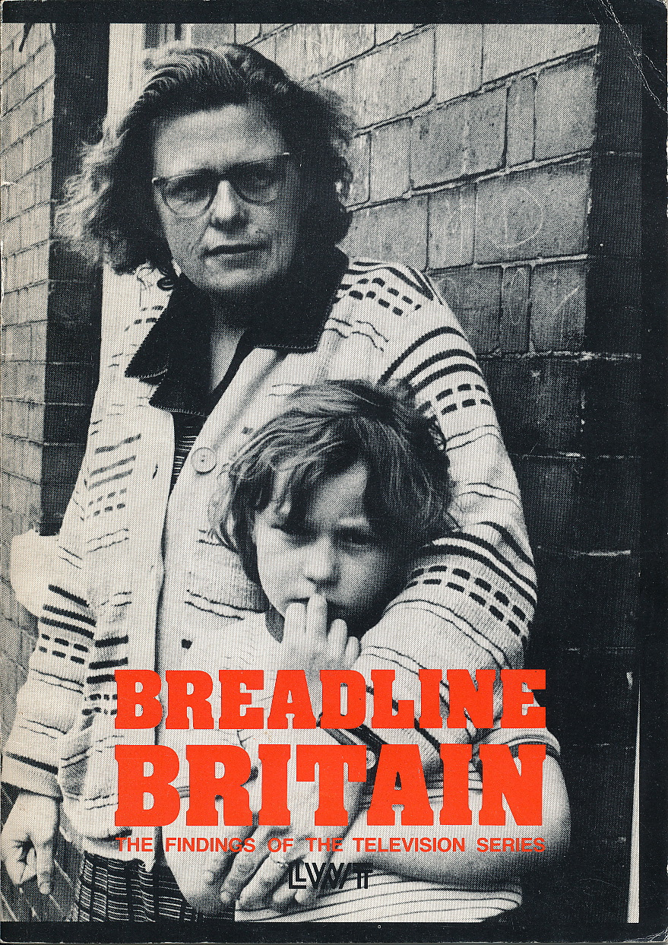

BREADLINE
BRITAIN

This booklet is written by Stewart Lansley and Joanna Mack, and prepared for publication by Paul Coueslant and published by London Weekend Television

The Breadline Britain programmes were produced by Joanna Mack and researched by Stewart Lansley and Su Wilkins. The director of the MORI survey was Brain Gosschalk.

A more detailed analysis of the programmes’ findings will be published as Poor Britain by George Allen & Unwin in 1984.
BREADLINE
BRITAIN
“We’ve just got to accept until I get a job we will be poor.”
Roy, 35, married, three children, unemployed for over three years.

“Well, it’s hard. It’s the most difficult task to get by.”
Ernie, 79, pensioner living alone

“I can’t cope on the money, and I can’t cope living here.”
Pamela, 23, single parent, one child aged 9 months

“I feel destitute, not poor.”
Mavis, 59, blind, partially deaf, diabetic, unemployed

“I consider I’m poor, and if you look at other people – working people – you’re at the bottom.”
Tricia, 26, single parent, two children

This is how people in Britain in 1983 have described what it is like to be poor. Typically, their poverty is not the grueling hardship and squalor that prevailed in Victorian Britain and before the Second World War. That type of poverty has mostly gone. But it has been replaced by a new type of poverty: resources so low as to exclude people from ordinary living patterns and activities, incomes insufficient to provide a living standard considered normal and essential by the great majority of the population.
London Weekend Television’s series Breadline Britain looked at the experiences of seven people and their families in Birmingham, Liverpool, London and Manchester, and commissioned Market and Opinion Research International (MORI) to find out people’s views on what constitutes an unacceptably low living standard in contemporary Britain, to what extent people fall below this standard and how standards vary.
This booklet reports Breadline Britain’s findings.
The Supplementary Benefits standard
Although there is no official definition of poverty, the level of income provided to people living on Supplementary Benefit is usually taken as the ‘official’ poverty line in Britain today. Supplementary Benefit is the minimum income set by the state below which those not in full-time work are expected to fall. How much is it worth? As from November 1982:
- An unemployed married couple receive £41.70 a week plus housing costs
- An unemployed couple with two young children receive £59.20 plus housing costs
- A single parent with a young child gets £41.45 plus housing costs
- A pensioner couple receive £52.30 plus housing costs
For many hears now, studies have shown that it is very difficult to manage on incomes like these, especially when there are children. In 1977, the Department of Health and Social Security and the now-defunct Supplementary Benefits Commission argued in evidence to the Royal Commission on the Distribution of Income and Wealth:
“The evidence regarding the standards of living of supplementary benefits recipients strongly suggests that the supplementary benefits scheme provides… incomes that are barely adequate to meet their needs at a level which is consistent with full participation in the life of the relatively wealthy society in which we live.”
Yet the relative value of Supplementary Benefit is no higher now than when this statement was made. Moreover, the number of people dependent on Supplementary Benefit has been rising sharply. In the mid-1950s, there were 1.6 million claimants of National Assistance (the means-tested benefit which was Supplementary Benefit’s predecessor). By 1970, 2.7 million were claiming Supplementary Benefit and the number had risen to 4.3 million in February 1983. There are now no less than 7.1 million people in households dependent on Supplementary Benefit – nearly one in seven of the population, and a rise of 60 per cent since 1979. Most of the increase is accounted for by a sharp rise in the number of unemployed claimants, from 566,000 in 1979 to 1.7 million in 1983. Moreover, according to the Department of Health and Social Security, the trend is still upwards.
Life on the poverty line
How well then do people living on the margins of poverty manage? They often miss out on meals. One single parent told Breadline Britain:
“I can’t cope with it. Sometimes I have to go hungry in order to feed the child. For two or three days at a time, I go without food. I just drink a cup of tea.”
They have difficulty with heating, many getting into serious debt with fuel bills and some getting cut off. Others just use less heat than they need or pay for heating by cutting back elsewhere. An unemployed couple with an asthmatic son told Breadline Britain:
“We can’t afford to heat upstairs. It’s very cold upstairs for him.”
They depend heavily, sometimes entirely, on second-hand clothes from jumble sales and friends:
“I’m not so worried about getting little bits and pieces for myself, but I’d like to buy the kids new things now and again – but it’s finding the money.”
They can’t afford toys and presents. An unemployed family about their 13 year old son:
“I mean it was Tony’s birthday four months ago. He is still waiting for his birthday present… I think they feel a bit let down that we can’t buy them new things.”
Or holidays. A family on low pay:
“The children have never had a holiday. They don’t know what it’s like to have a holiday. I can’t afford it. I wish we could but we can’t.”
So, in Britain today, the poor often go without the things that most people take for granted. They are better off than the poor of the past, but they are still badly off in comparison with the rest of society. But we measure poverty by today’s standards, not by those of the past. In general, the gap between the poor and the rest has not changed much since the turn of the century. It narrowed during and after the Second World War, stayed about the same until the late 1970s and has widened again since then. The question remains as to whether that gap is too wide.
33 items ranked by percentage of survey sample describing them as essential, and percentage of sample lacking items because they can’t afford them
 | Described as Essential by % | Lacked by % |  | Described as Essential by % | Lacked by %
Heating to warm living areas of the home if it is too cold | 97 | 6 | New, not second-hand clothes | 64 | 8
Indoor toilet (not shared with another household | 96 | 1 | Hobby or leisure activity | 64 | 9
Damp-free home | 96 | 8 | 2 hot meals a day | 64 | 4
Bath (not shared with another household) | 94 | 2 | Meat or fish every other day | 63 | 9
Public transport for one’s needs | 88 | 3 | Presents for friends or family once a year | 63 | 5
Warm waterproof coat | 87 | 7 | Holiday away from home for 1 week a year, not with relatives | 63 | 23
3 meals a day for children | 82 | 4 | Leisure equipment for children, eg sports equipment or bicycle | 57 | 13
Self-contained accommodation | 79 | 3 | Television | 51 | <0.5
2 pairs of all-weather shoes | 78 | 11 | ‘Best outfit’ for special occasions | 48 | 13
Enough bedrooms for every child over 10 of different sex to have own bedroom | 77 | 10 | Telephone | 43 | 11
Refrigerator | 77 | 1 | Outing for children once a week | 40 | 25
Toys for children (for families with children only) | 71 | 3 | Dressing gown | 38 | 3
Carpets in living rooms and bedrooms | 70 | 2 | Children’s friends round for tea or snack once a fortnight | 37 | 15
Celebrations on special occasions like Christmas | 69 | 4 | Night out once a fortnight (adults) | 36 | 18
Roast joint or equivalent once a week | 67 | 7 | Friends or family round once a fortnight | 32 | 13
Washing machine | 67 | 5 | Car | 22 | 24
 |  |  | Packet of cigarettes every other day | 14 | 6

THE BREALINE BRITAIN SURVEY
To find out whether the living standards of those people on the lowest incomes are unacceptable in relation to the rest of society, Breadline Britain commissioned the MORI survey. A representative sample of 1174 people throughout Britain were asked about their view on what constitutes an unacceptable low standard of living in 1983.
In particular, the Breadline Britain survey asked which of a list of 33 items (see the table overhead) the respondents thought were necessary and which all people should be able to afford, and which they should not have to do without. The list is inevitably not comprehensive and does not include everything that might be necessary. It was designed to be representative of living standards by covering a cross-section of a household’s social and personal life, including diet, heating, household durables and amenities, social activities and clothing. Before the list was drawn up, it was discussed with experts and groups of people on low incomes across the country. It was then tested with a trial run. The final list does not include things like salt, which almost everyone has, nor things such as pocket calculators which few people would miss.
A minimum standard of living
The survey found that more than two-thirds of people thought that the following items were necessities:
- Heating
- An indoor toilet
- A damp-free home
- A bath (not-shared)
- Enough money for public transport
- A warm waterproof coat
- Three meals a day for children
- Self-contained accommodation
- Two pairs of all-weather shoes
- No overcrowding, with enough bedrooms for children
- A refrigerator
- Toys for children
- Carpets
- Celebrations for special occasions such as Christmas
- A roast joint or its equivalent once a week
- A washing machine
Other items considered necessities by more than half but less than two-thirds of people were:
- New, not second-hand clothes
- A Hobby or leisure activity
- Two hot meals a day for adults
- Meat or fish every other day
- Presents for friends and family once a year
- Holidays away from home for one week per year
- Leisure equipment for children
- A television
This shows a considerable consensus in society on what a minimum standard should be. It also shows how important it is that such minimum standards should be raised in line with improvements in general living conditions. Most of the items considered to be essential by a majority of people would not have appeared in the subsistence standards of the past.
To test how strongly people felt about these necessities, the survey asked people if they would be prepared to pay 1p in the £ more income tax to enable everyone to afford the items they said were necessities: 74 per cent supported an increase of this amount, and 23 per cent opposed it. This is an overwhelming endorsement that these necessities do set a minimum standard of living for Britain today, which people strongly believe in.
How many go without?
The Breadline Britain survey also asked people about their own living standard – which items they had and which they did not have because they could not afford them. People were also asked which items they don’t have but don’t want, since some people choose not to have items even though they can afford them. The proportion of people lacking items because they can’t afford them is shown in the table.
This is what the survey showed when applied to the population as a whole:
- Approximately 3 million people in Britain today cannot afford to heat the living areas of their homes
- Around 6 million people go without some essential aspect of clothing – such as a warm waterproof coat – because of lack of money
- Some 1 ½ million children go without toys or, for older children, leisure and sports equipment because their parents don’t have enough money
- Nearly 3 ½ million people don’t have consumer durables such as carpets, a washing machine or a fridge because of lack of money
- Around 3 million people can’t afford celebrations at Christmas or presents for the family once a year
- At least 5 ½ million people regularly go without some essential food item, such as a roast joint, once a week
- Nearly 1 ½ million children do not have three meals a day because their parents are so short of money
These figures present a stark picture of poverty in Britain today. They are even more significant because of the Breadline Britain survey’s finding of a public consensus that people should not have to do without those items.
The findings are also taken a step further. The list of items classed as necessities by a majority of people was used to determine which people and how many are poor. For the first time ever, the poor in Britain have been identified on the basis of those who fall below the minimum standard of living laid down by society.
The results show that a few of the people who cannot afford one or two of these necessities are not on low incomes. But those who cannot afford three or more necessities are heavily concentrated among those on the lowest incomes. On this basis 7 ½ million people in Britain today – one in seven of the population – are poor. Five and a half million – one in ten – cannot afford five or more necessities, a level of deprivation that affects their whole way of life. And among the poor, many live in intense poverty. Three-quarters of a million people cannot afford most of the necessities for living in Britain today.
Who are the poor?
Who are those lacking three or more of these items? Breadline Britain found that the poor fell into five groups: the unemployed; single parents; the sick and disabled; pensioners and low-paid workers.
Among these, the two groups most at risk are the unemployed and single parents. Among single parents, those with younger children are especially at risk, among the unemployed deprivation rises with the length of unemployment.
The next most vulnerable group is the sick and disabled. As a group, pensioners are less at risk, though this may be due to lower expectations. Many did not think of themselves as having a particularly low standard of living. Among them, single pensioners are poorer than couples and living standards decline with age as resources dwindle.
Least at risk are families with a head of household in full-time work, and in families with two wage-earners these is little chance of ending in poor. But there are large numbers of families in which the wife does not work and the husband’s wages are too low to meet the costs of bringing up children.
Risk tells us what proportion of a particular group are likely to be deprived. But also important is what proportion these groups constitute of all the poor. This depends on the overall size of the group in the population. For example, even though single parents have a high risk of being poor, they only constitute a small proportion of all those in poverty, because they account for a relatively small proportion of the population.
The survey found that three groups – the unemployed, the sick and disabled, and those households with a head in full-time work – accounted for most of those lacking necessities. In contrast, single parents and pensioners accounted for fewer of the poor. These groups also overlap to some degree. Some people, for example, will be disabled and unemployed, some single parents and unemployed.
Other characteristics
The lifestyle of the poor is not only reflected in a lack of necessities. According to the Breadline Britain survey, households with low incomes were especially vulnerable to getting into debt. Of the poorest 5 per cent of households in the sample, over half had been in serious arrears with gas and electricity bills, rent or hire purchase payments, compared with 16 per cent of the sample as a whole. The poor are also twice as likely to have to resort to borrowing from friends or family.
The poor are much more likely to be depressed, lack hope for the future or worry about not having enough money to make ends meet. Only 27 per cent of the poor suffered none of these worries, compared with 58 per cent of all households. Of the poorest, 47 per cent were dissatisfied with their living standards compared with 17 per cent of all households.
To find out whether people feel deprived, the survey asked whether you could genuinely say you are poor now/all the time/sometimes/never? Among those lacking three or more items from the selected bundle of necessities, as many as 51 per cent felt poor all the time and 33 per cent sometimes – a huge majority. This compares with 12 per cent and 28 per cent respectively for the whole sample.
Where do the poor live? The survey found that a sharp north/south divide with a heavy concentration of the poor in the Midlands and the North. No less than 71 per cent live in these regions. One tenth of the poor live in London and one fifth in the rest of the South. Forty-two per cent live in cities in the North and Midlands.
Public attitudes to the poor
The survey also tested how sympathetic people were to the poor. First, they were asked why people lived in need. Twenty-three per cent said it was due to ‘laziness and lack of willpower’, 33 per cent to ‘too much injustice’, 13 per cent because ‘they were unlucky’ and 26 per cent because ‘it’s an inevitable part of modern progress’. These contrast sharply with the answers to an identical question asked in 1976. Then, nearly double – 43 per cent – said that laziness and lack of willpower were the main cause, and only 10 per cent attributed poverty to injustice. Since the mid-1970s people seem to have become more sympathetic to the plight of the poor.
Public sympathy is also confirmed by answers to other questions. Thus, 57 per cent thought that the government is doing too little to “help those who lack those things you have said are necessities” while only 6 per cent thought too much was being done.
The strength of support for measures to help the poor has already been quoted on page 9: 74 per cent said they would support an increase in income tax of 1p in the £ to enable everyone to afford necessities. Thirty-five per cent would support an increase of 5p in the £, with the same percentage being opposed. Turning a 1p increase in income tax into hard cash shows that the net effect could be a rise in Child Benefit from £5.85 to around £7.85 , or a rise in Retirement Pension for a couple from £52.55 to approximately £57.80, or an increase in the long-term rate of Supplementary Benefit for a couple from £52.30 to around £63.80.
The survey also found – perhaps surprisingly – substantial public support for reductions in inequality:
- 76% agreed that differences in pay between the highly and lowly paid were too great, while 20% disagreed.
- 63% were in favour of higher taxes on the rich with 32% against
- 74% thought that the gap between the rich and poor is too wide with 21% disagreeing
- 66% supported the introduction of a minimum wage, and 38% thought it should be over £90 a week
These findings are, of course, not enough in themselves to effect the specific changes which might be made to help the poor. It is the interpretation of public opinion by Governments in their formulation of social policies that determines whether poverty in Britain is tolerated, alleviated or eliminated. Breadline Britain’s findings are put forward as a contribution to the debate about these policies.

Selected Reading
Rowntree, B. Seebohm. Poverty: a study of town life, McMillan, 1901, (2nd edition 1910). Garland Publishing, 1980 (reprint of 1910 edition)
2010 edition:
- ISBN-10: 1145153283
ISBN-13: 978-1145153288
Rowntree, B. Seebohm. Poverty and progress, Longman, 1941
Social Insurance and Allied Services (The Beveridge Report) Cmnd 6404, HMSO 1942.
http://www.fordham.edu/halsall/mod/1942beveridge.html

Rowntree, B. Seebohm, Poverty and the Welfare State, Longman, 1951
Titmuss, Richard M. Income distribution and social change, Allen & Unwin, 1962,
ASIN: B0000CLIHR
Tawney, R.H. Equality, Allen & Unwin, 1965
- ISBN-10: 0043230148
ISBN-13: 978-0043230145
Feigehen, Guy C et al. Poverty and Progress in Britain 1953-73, Cambridge University Press, 1977
Royal Commission on the Distribution of Income and Wealth, Background Paper to Report No. 6 (The Causes of Poverty), HMSO, 1978
Harris, R. and Seldo, A. Over-ruled on welfare, Hobart Paper No. 13, Institute of Economic Affairs, 1979
Joseph, Sir Keith and Sumpton, Jonathan. Equality, John Murray 1979
Townsend, Peter. Poverty in the United Kingdom, Penguin, 1979.
Goldthorpe, John Harry et al. Social mobility and class structure in modern Britain, Oxford University Press, 1980.
Halsey, A.H. et al. Origins and destinations: family, class and education in modern Britain. Oxford University Press, 1980.
Field, Frank. Inequality in Britain: freedom welfare and the state, Fontana, 1981.
Brown, M. and Madge, N. Despite the Welfare State, Heinemann Educational, 1982.
Le Grand, Julian. Strategy of equality: redistribution and the social services, Allen & Unwin, 1982.
Townsend, Peter. And Davidson, Nick. Inequalities in health, Penguin, 1982.
Wedge, Peter and Essen, Juliet. Children in adversity, Pan, 1982.
The Structure of Personal Income Taxation and Income Support, House of Commons Session 1982-3 HC386.
Bull, D. and Wilding P. Thatcherism and the poor, Child Poverty Action Group, 1983.

